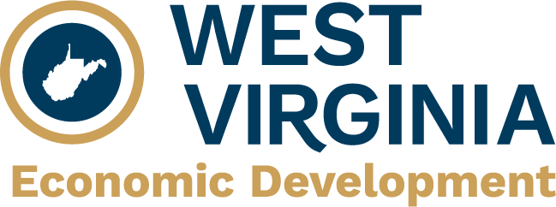

1900 Kanawha Boulevard, East

Building 3, Suite 600

Charleston, West Virginia 25305

(800) 982-3386 · (304) 558-2234

**westvirginia.gov**



**WEST VIRGINIA DEPARTMENT OF ECONOMIC DEVELOPMENT (WVDED)**

**broadband loan insurance and incentives – intent to participate**

|  |  |
| --- | --- |
| Applicant/Company |  |

The Broadband Loan Insurance (BLINS) Program assists businesses in gaining access to credit from West Virginia financial institutions and is administered by the West Virginia Economic Development Authority (WVEDA). Through Senate Bill 2035, passed during the 2024 Extraordinary Session of the West Virginia Legislature, additional funding is available for loan insurance and other incentives to broadband service providers who may participate in West Virginia’s federally funded BEAD grant programs. Those interested in learning more about BLINS should contact the WVEDA at [eda.wv.gov/programs/broadband-loan-insurance/](https://eda.wv.gov/programs/broadband-loan-insurance/).

This form indicates the Applicant’s intent to seek BLINS assistance in connection with an application to WVDED for funding under the West Virginia BEAD Program, including the Application Extension to that program. See [broadband.wv.gov](http://broadband.wv.gov) for more information. This information will help WVDED to understand BLINS loan insurance and other incentives which may be available to the Applicant and facilitate coordination between WVDED and WVEDA.

**Check all that apply and indicate the dollar amount of assistance sought for each category.**

Letter of Credit Insurance $______________

Bank Loan Insurance $______________

Incentives to participate in federally funded broadband expansion programs $______________

Please upload this document to the MASV folder associated with the Applicant’s pre-application to the West Virginia BEAD Program. To allow WVDED to consider an applicant’s intent to participate when evaluating its broadband grant funding applications, applicants submitting proposed projects to the West Virginia BEAD Program Full Application round closing October 24, 2024, are strongly encouraged to **submit this form by November 1, 2024**. Applicants submitting proposed projects to the Application Extension may submit this form at the same time as submitting a proposal to the Extension but are encouraged to do at the soonest possible date.

**This form is not an application to BLINS.  
  
Applicants must apply to WVEDA to receive broadband loan insurance assistance  
or other incentives.**